**Word of Life: November 2021**

*Recommended dates are provided, but you are welcome to use these materials at any time!*

**Featured this Month…**

* **November is National Adoption Awareness Month!**This occasion is an opportunity to highlight the gift of adoption. Resources are available to assist you in supporting and praying for all whose lives are touched by adoption:

[Novena to St. Joseph:](https://www.respectlife.org/adoption-novena)

[For Those on the Path of Adoption](https://www.respectlife.org/adoption-novena)

[Accompanying Expectant](https://www.respectlife.org/mothers-considering-adoption)

[Mothers Considering Adoption](https://www.respectlife.org/mothers-considering-adoption)

[An Adoption](https://www.respectlife.org/adoption-love-story)

[Love Story](https://www.respectlife.org/adoption-love-story)

**Walking with Moms Prayer Guide**

**November 2021**

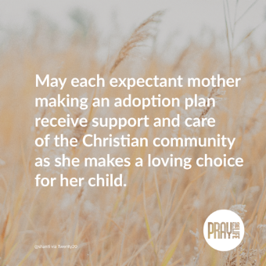**Sample Announcement**

Find prayer guides for the whole year at [walkingwithmoms.com/pray-for-moms](http://www.walkingwithmoms.com/pray-for-moms)!

**Image and Prayer Guide (print version)**

<https://www.usccb.org/resources/wwmin-prayer-guide-11>

**The Solemnity of Our Lord Jesus Christ, King of the Universe   
November 21, 2021**

[Resources are being made available](http://www.usccb.org/issues-and-action/religious-liberty/christ-the-king/index.cfm) to help educate the faithful about the Solemnity of Christ the King and its connection to religious liberty.

21

**Word of Life – November 2021**

**Intercessions for Life**

|  |  |
| --- | --- |
| **November 7th**  For all public officials, especially those newly elected: May they strive to govern with the wisdom of God,  and protect life from conception to natural death;  *We pray to the Lord:* | **Thirty-second Sunday  in Ordinary Time** |
| **November 14th**  For married couples considering adoption:  May the Holy Spirit guide their discernment,  grant them peace, and bring to fruition his holy will;  *We pray to the Lord*: | **Thirty-third Sunday in Ordinary Time** |
| **November 21st**  On this feast of Christ the King and always:  May all recognize God as the author of life  and give thanks for His precious gift;  *We pray to the Lord:* | **The Solemnity of Our Lord Jesus Christ, King of the Universe** |
| **November 28th**  For all the faithful:  May the Lord help us build a culture of life  in vigilant expectation of His return;  *We pray to the Lord*: | **First Sunday of Advent** |

**Word of Life – November 2021**

**Bulletin Quotes**

|  |  |
| --- | --- |
| **November 7th**  “We know earthly death is not the end, but rather the door through which we must pass to gain eternal life. Because of our belief and hope in the Resurrection, we can face death not with fear, but with preparation… We prepare for eternal life by choosing to love and follow God now, in our daily lives and decisions.”  USCCB Secretariat of Pro-Life Activities,  “Catholic Considerations for Our Earthly Passing”  respectlife.org/end-of-life-considerations | [Order](http://store.usccb.org/Catholic-Considerations-for-Our-Earthly-Passing-p/c1744.htm) | [Download](https://www.usccb.org/about/pro-life-activities/respect-life-program/2017/upload/rlp-17-end-of-life-flyer-color-secure.pdf)  [Online](https://www.usccb.org/about/pro-life-activities/respect-life-program/2017/upload/rlp-17-end-of-life-flyer-color-secure.pdf) |
| **November 14th**  “We can’t imagine loving a child whom we conceived more than we love Andrew. It is amazing how he fits our personalities so well… Adopting Andrew has made us more aware of God’s power and of his love for us. We realize that he always has a perfect plan for our lives.”  USCCB Secretariat of Pro-Life Activities,  “An Adoption Love Story” (respectlife.org/adoption-love-story) | [Order](http://store.usccb.org/product-p/c1445.htm) | [Download](https://www.usccb.org/about/pro-life-activities/respect-life-program/2014/upload/An-Adoption-Love-Story-RLP2014-Bulletin.pdf)  [Online](https://www.usccb.org/about/pro-life-activities/respect-life-program/2014/upload/An-Adoption-Love-Story-RLP2014-Bulletin.pdf) |
| **November 21st**  “The right to religious freedom has its foundation in the very dignity of the human person.”  Pope Paul VI, *Dignitatis humanae* (*Declaration on Religious Freedom*), 2.  © 1965 Libreria Editrice Vaticana. Used with permission. All rights reserved. | Index  [Read Online](http://www.vatican.va/archive/hist_councils/ii_vatican_council/documents/vat-ii_decl_19651207_dignitatis-humanae_en.html) |
| **November 28th**  “Having received the gift of the Gospel of Life, we are the people of life and a people for life. It is our duty to proclaim the Gospel of Life to the world. To proclaim Jesus is to proclaim life itself. Gratitude and joy at the incomparable dignity of the human person impel us to bring the Gospel of life to the hearts of all people and make it penetrate every part of society.”  USCCB Secretariat of Pro-Life Activities “The Gospel of Life: A Brief Summary”  respectlife.org/gospel-of-life-summary | [Download](https://www.usccb.org/resources/rlp-20-bulletin-insert-ev-summary_0.pdf) | [Read Online](https://www.respectlife.org/gospel-of-life-summary)  [Online](https://www.respectlife.org/gospel-of-life-summary) |

**Word of Life - November 2021**

**Bulletin Art**

*You are welcome to use these and other downloadable images from the online* [**Respect Life image gallery**](https://www.respectlife.org/respect-life-image-gallery)*, provided they are not altered in any way, other than the size. Thank you!*

**Sunday, November 14th, 2021**

* 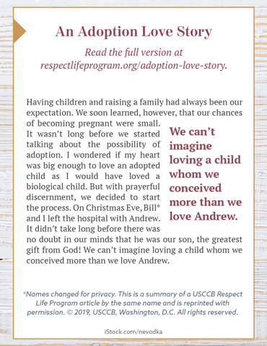**Image (Color):** [English](https://static.wixstatic.com/media/c138fd_501830b028e94988a3194a0cf2f25c6b~mv2_d_1275_1650_s_2.png/v1/fill/w_1275,h_1650/rlp-19-bulletinboxes-adoption-love-story.png) | [Spanish](https://static.wixstatic.com/media/c138fd_450c9454c6c14392a21ec93eea9caee2~mv2_d_1275_1650_s_2.png/v1/fill/w_1275,h_1650/rlp-19-bulletinboxes-adoption-spn.png)
* **Image (Grayscale):** [English](https://static.wixstatic.com/media/c138fd_b885ed7c069f4b1793b1b0683a9ceeb7~mv2_d_1275_1650_s_2.png/v1/fill/w_1275,h_1650/rlp-19-bulletinboxes-adoption-love-story-bw.png) | [Spanish](https://static.wixstatic.com/media/c138fd_f637ad169153461e989ff8d1cba3a048~mv2_d_1275_1650_s_2.png/v1/fill/w_1275,h_1650/rlp-19-bulletinboxes-adoption-spn-BW.png)
* **Quote Source:** [An Adoption Love Story](https://www.respectlife.org/adoption-love-story) (See bottom of the [webpage](https://www.respectlife.org/adoption-love-story) for additional formats.)

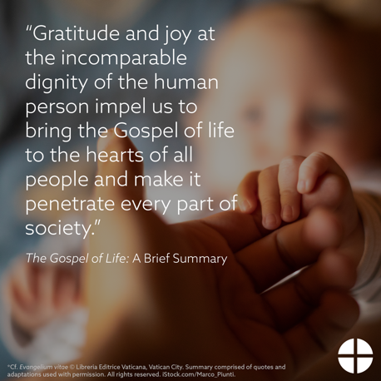**Sunday, November 28th, 2021**

**Online Article:** [*The Gospel of Life:* A Brief Summary](https://www.respectlife.org/gospel-of-life-summary)

**Image, Bulletin Insert PDF, and Word Doc**

<https://www.usccb.org/resources/gospel-life-brief-summary>